**@Input( )**

***Use the @***[***Input***](https://angular.io/api/core/Input)***() decorator in a child component or directive to let Angular know that a property in that component can receive its value from its parent component. It helps to remember that the data flow is from the perspective of the child component. So an @***[***Input***](https://angular.io/api/core/Input)***() allows data to be input*into*the child component from the parent component.***

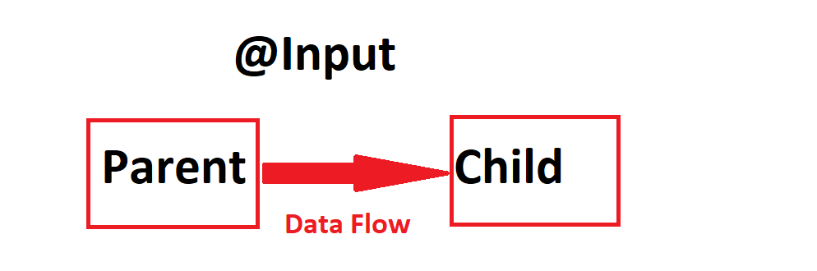

## In the child

***To use the @***[***Input***](https://angular.io/api/core/Input)***() decorator in a child component class, first import***[***Input***](https://angular.io/api/core/Input)***and then decorate the property with @***[***Input***](https://angular.io/api/core/Input)***():***

***user-edit.ts***

import { Component, OnInit,Input } from '@angular/core';

@Component({

  selector: 'app-user-edit',

  templateUrl: './user-edit.component.html',

  styleUrls: ['./user-edit.component.css']

})

export class UserEditComponent implements OnInit {

  constructor() { }

   @Input() name:string;

  ngOnInit(): void {

  }

}

***user-edit.html***

<h4>Name::{{name}}</h4>

***user-home.ts***

import { Component, OnInit } from '@angular/core';

@Component({

  selector: 'app-home',

  templateUrl: './home.component.html',

  styleUrls: ['./home.component.css']

})

export class HomeComponent implements OnInit {

  myName:string="Nani"

  constructor() { }

  ngOnInit(): void {

  }

}

***user-home.html***

<app-user-edit [name]="myName"></app-user-edit>

***app.component.html***

<!DOCTYPE html>

<html lang="en">

<head>

  <meta charset="UTF-8">

  <meta name="viewport" content="width=device-width, initial-scale=1.0">

  <title></title>

</head>

<body>

  <app-home></app-home>

</body>

</html>

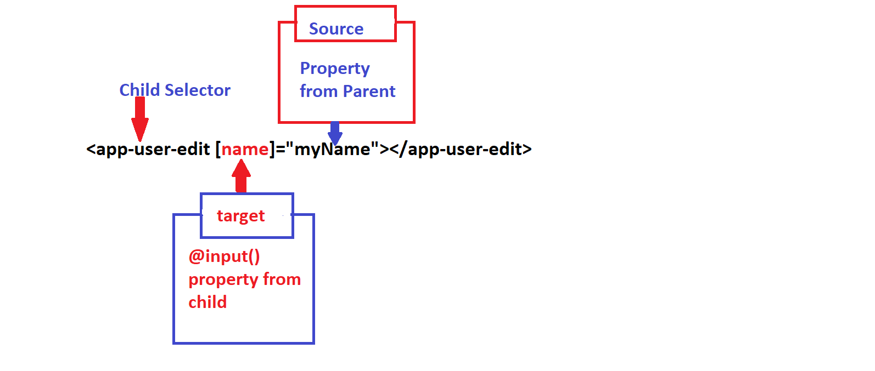

***Browser Output***

***Name:: Nani***